CSA4712 – Deep Learning

NAME: SAHASRA V
REG NO: 192424234
COURSE FACULTY: DR. UMA PRIYADARSINI

- VECTOR AND MATRIX OPERATIONS FOR DEEP LEARNING

Aim: To perform vector and matrix operations using NumPy and visualize the results using Matplotlib.
Description: Vector and matrix operations are essential mathematical computations in deep learning. NumPy is used to perform vector addition, matrix addition, subtraction, multiplication, transpose, and dot product operations. Matplotlib is used to visualize the results and understand the numerical computations.
Dataset: Numerical vectors and matrices containing sample values used to perform mathematical operations.
Python libraries: NumPy, Matplotlib.
Required outputs:
- Input vectors and matrices in table format.
- Results of vector and matrix operations.
- Comparisons of operation results in tables.
- Statistical summaries and detailed evaluation results.

CODE:
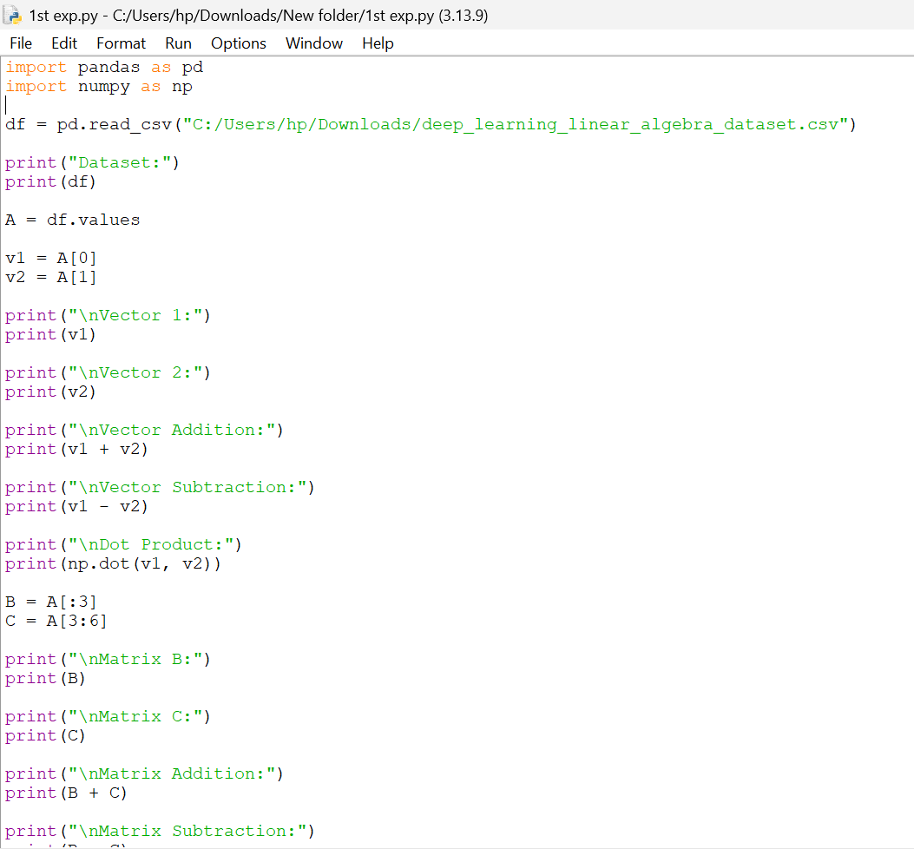

OUTPUT:

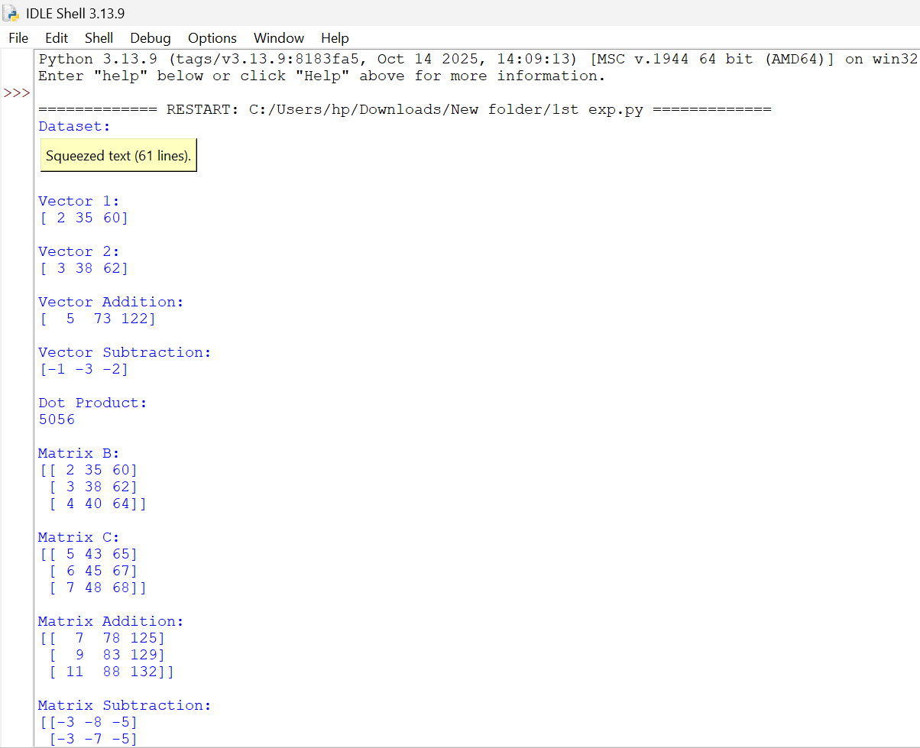

- COVARIANCE, EIGEN VALUES, EIGEN VECTOR ANALYSIS

Aim: To calculate covariance, eigenvalues, and eigenvectors using NumPy and Pandas and visualize the results using Matplotlib.
Description: Covariance measures relationships between variables. Eigenvalues indicate the variance associated with principal directions, while eigenvectors represent those directions. These concepts are used in statistical analysis and dimensionality reduction.
Dataset: Student performance dataset with more than 50 records, containing study hours, sleep hours, attendance, assignment scores, and exam scores.
Python libraries: NumPy, Pandas, Matplotlib.
Required outputs:
- Dataset samples in table format.
- Covariance matrix and descriptive statistics.
- Eigenvalues and eigenvectors.
- Evaluation results and comparisons in tables.
- Plots for covariance, eigenvalue comparison, and explained variance.
CODE:
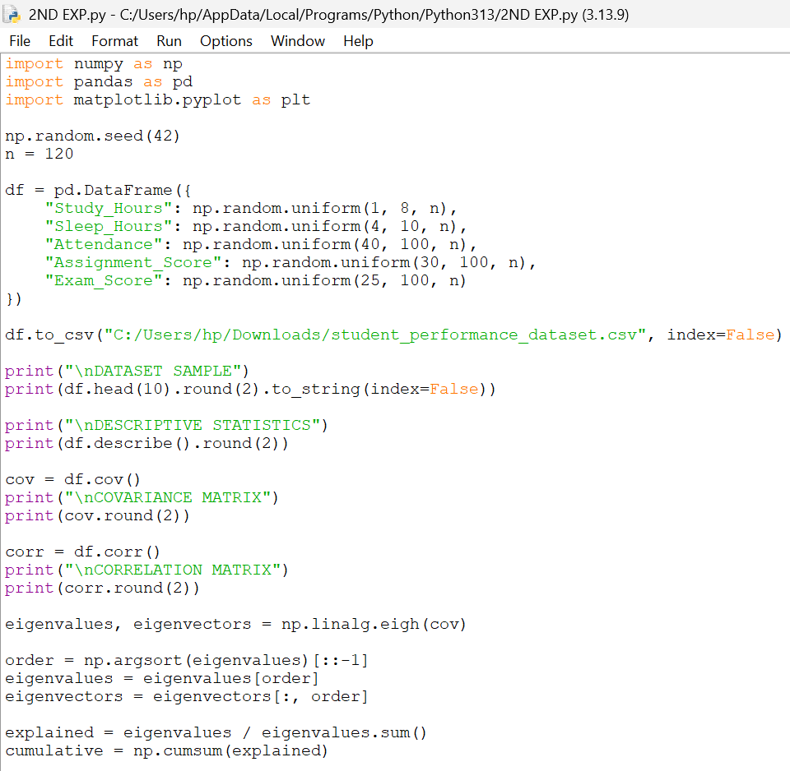
OUTPUT:
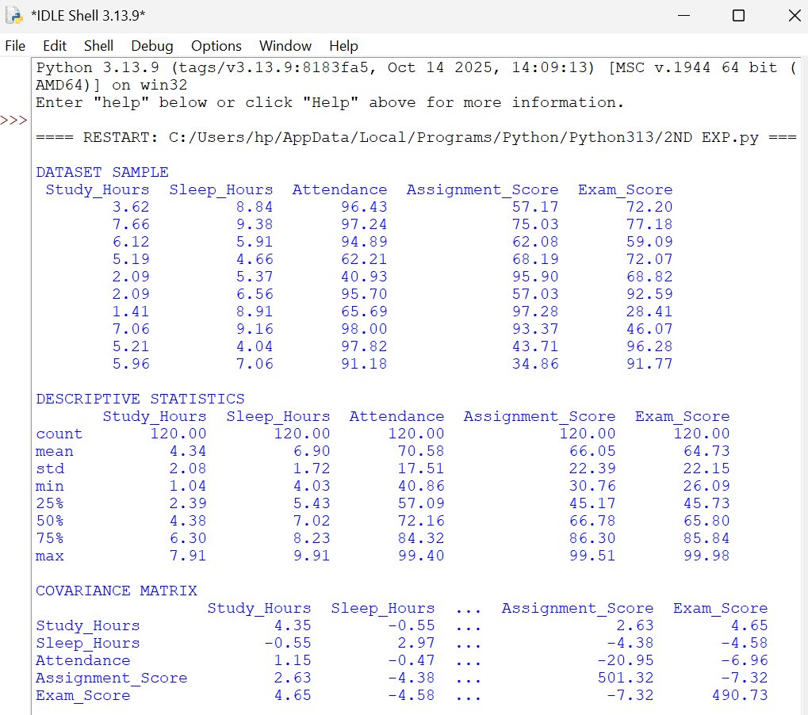

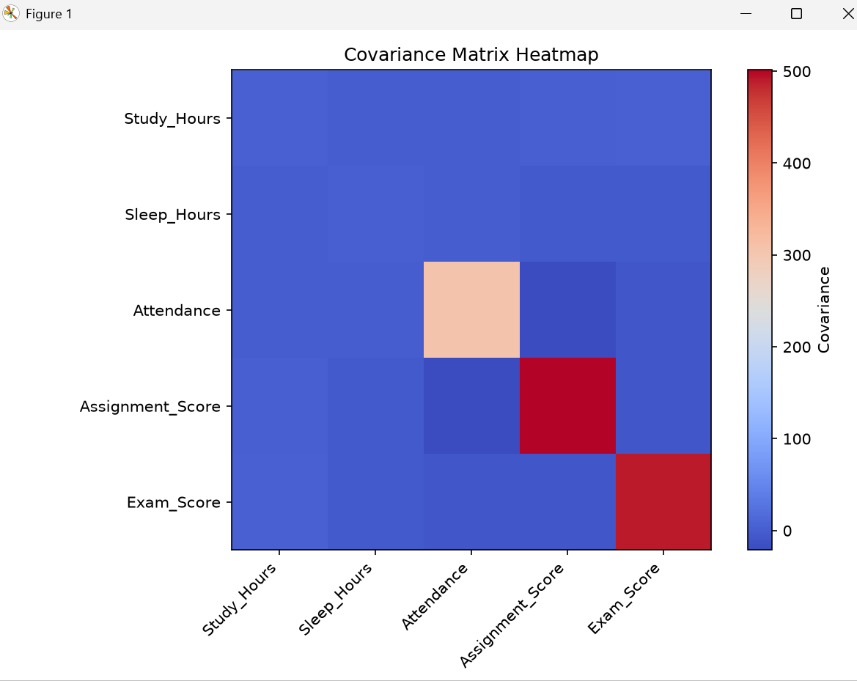

- PROBABILITY DISTRIBUTIONS AND BAYES’ THEOREM

Aim: To analyze probability distributions and apply Bayes’ theorem using Python, NumPy, Pandas, and Matplotlib.
Description: Probability distributions describe the likelihood of different outcomes in a random experiment. Discrete distributions, such as the Binomial and Poisson distributions, are used to model countable outcomes. Bayes’ theorem is used to calculate conditional probabilities and update the probability of an event based on new information. This experiment applies probability concepts to a dataset and visualizes the results using graphs.
Dataset: A dataset containing more than 50 observations related to event occurrences, success and failure outcomes, and conditional events.
Python libraries: NumPy, Pandas, Matplotlib, SciPy.
Required outputs:
- Dataset samples in table format.
- Probability distribution calculations and comparisons in tables.
- Bayes’ theorem calculations and conditional probability results.
- Statistical summaries and evaluation results.
- Plots comparing probability distributions and their probabilities.
CODE:
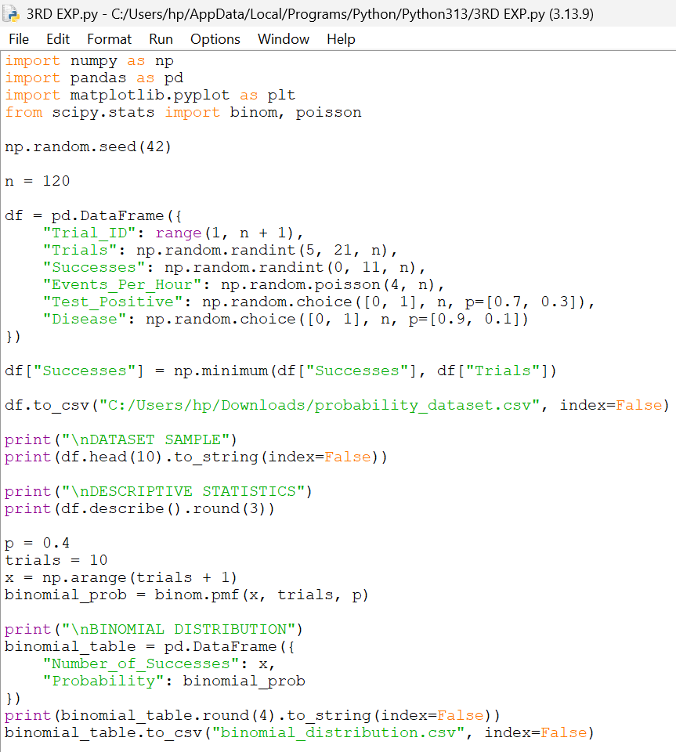
OUTPUT:
